What do the sum of the first 9 prime numbers add up to... (answer below)

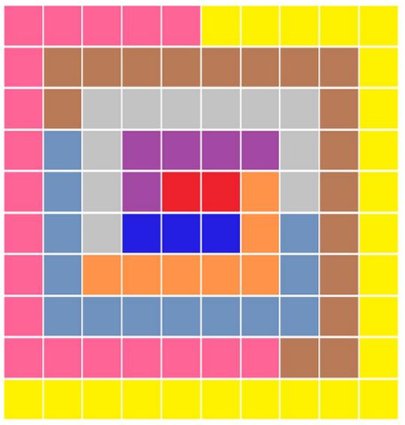

Do any other square numbers exist?